JAVAPROGRAMMING UNIT 1
PROGRAM 1: ARITHMETIC
Write a Java program that takes two integers as input from the user and calculates their sum, difference, product, and quotient using arithmetic operators.
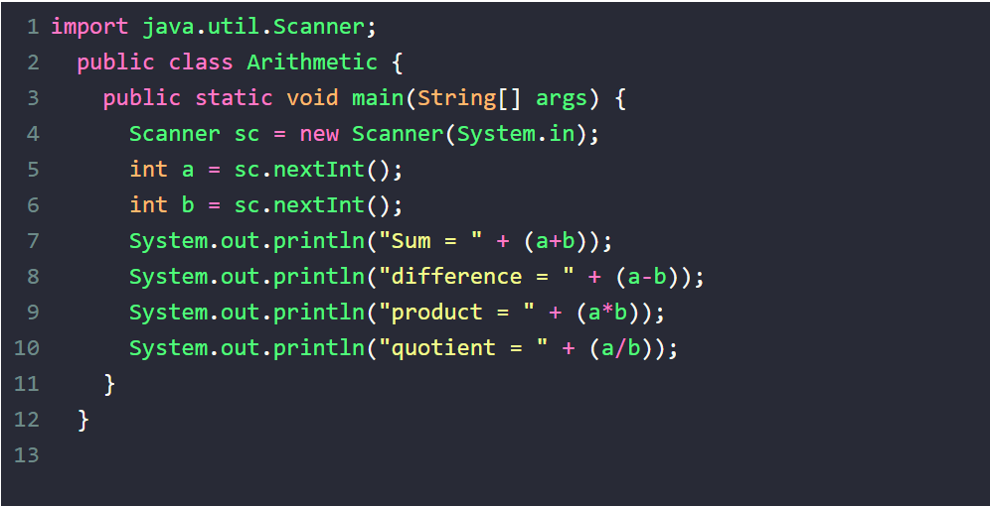
INPUT:
10 20
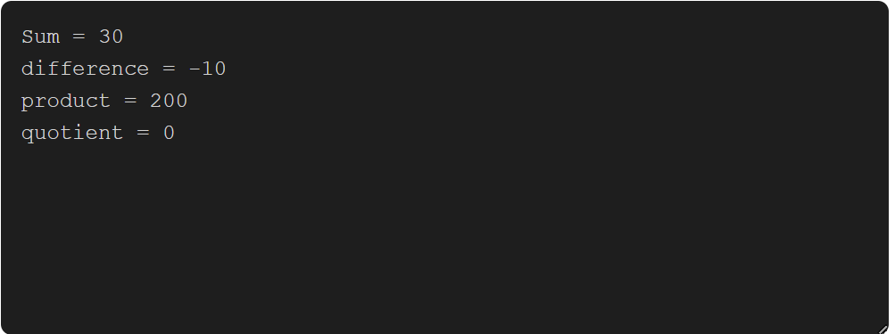
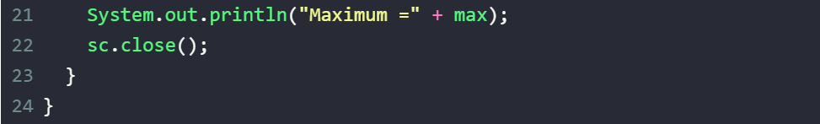
PROGRAM 2: MAX Write a Java program to find the maximum of three numbers using conditional statements.
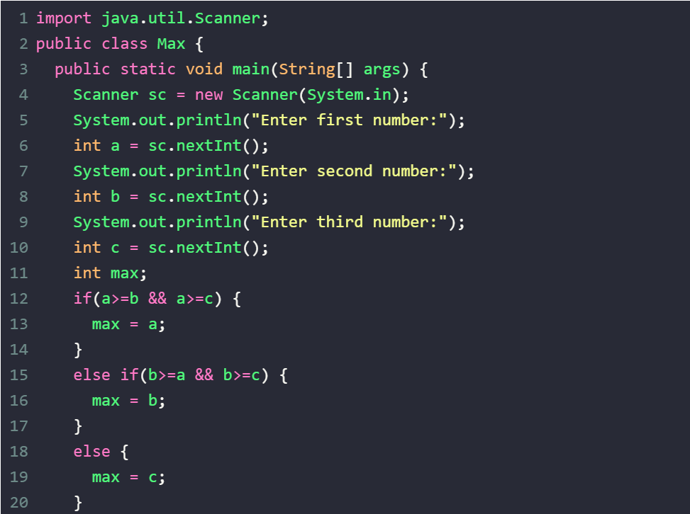
INPUT:
10 11 16
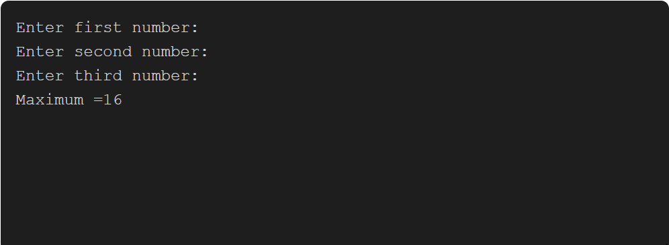
PROGRAM 3: LEAP Write a Java program to check whether a given year is a leap year or not using conditional statements.
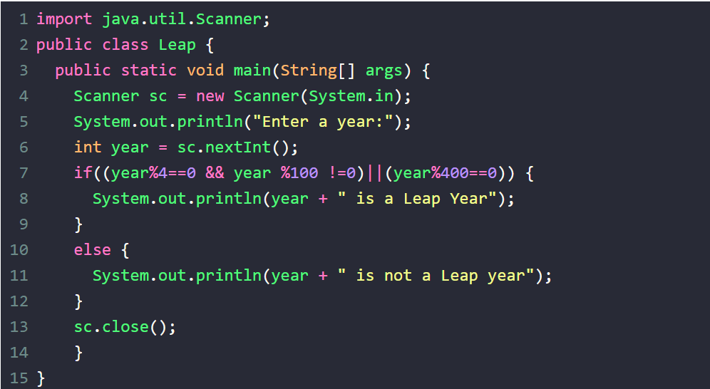
INPUT: 2008
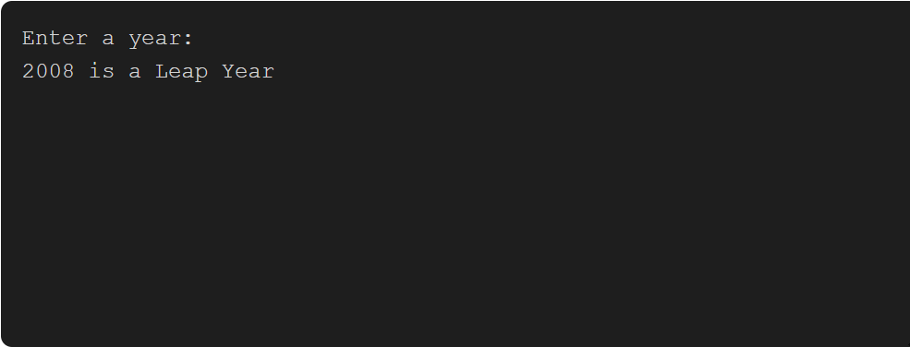

PROGRAM 4: FIBONACCI Write a Java program to print the Fibonacci series up to a given number using loops.
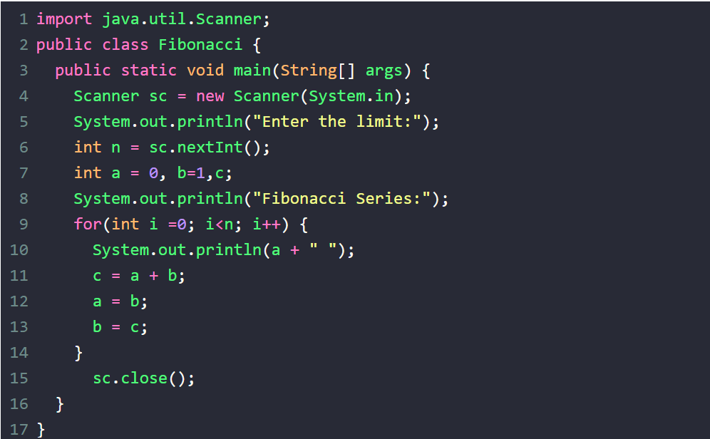
INPUT: 7
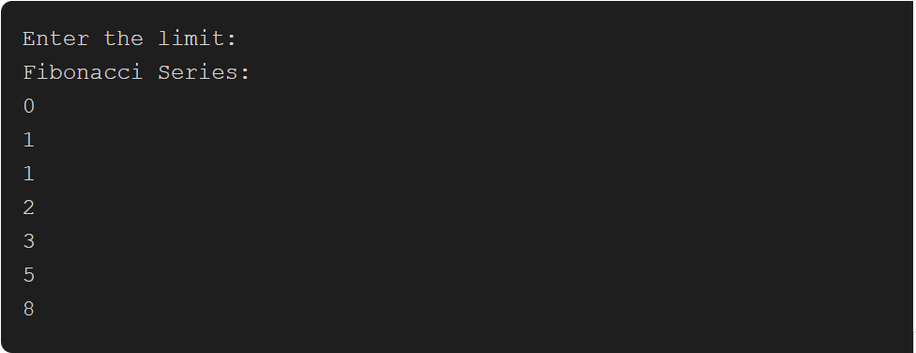

PROGRAM 5: FACTORIAL Write a Java program to calculate the factorial of a given number using loops.
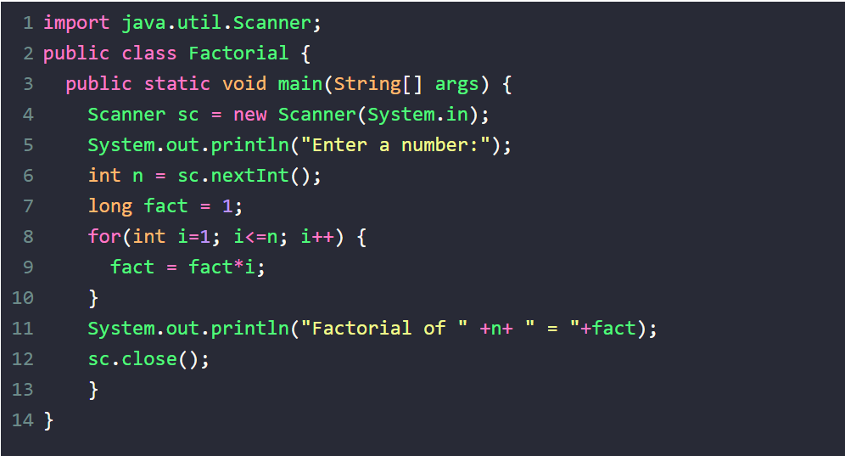
Input: 7
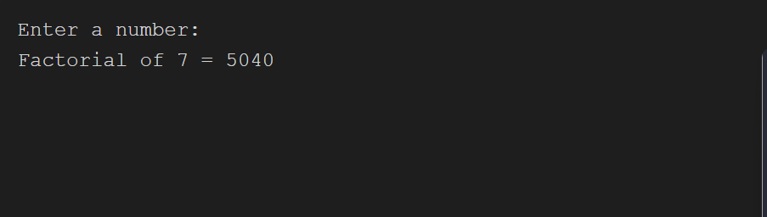

PROGRAM 6: RT-PATTERN Write a Java program to print the following pattern using loops:
*
**
***
****
*****
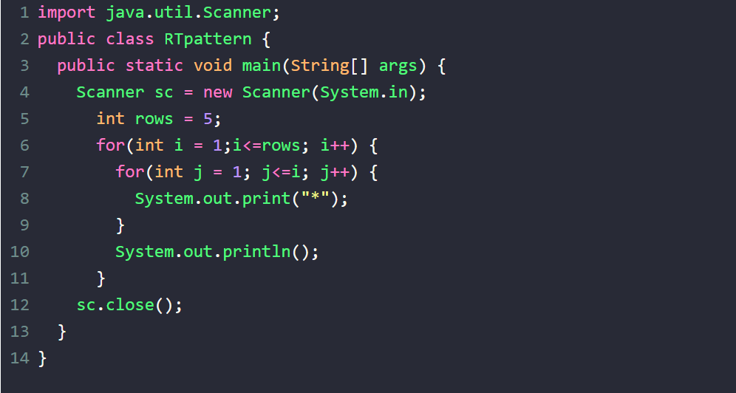
INPUT:
5
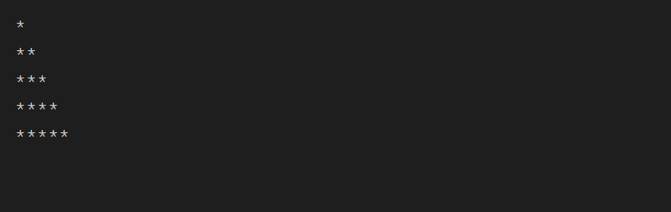

PROGRAM 7: SEARCH Write a Java program to implement binary search on an array of integers using loops and conditional statements.
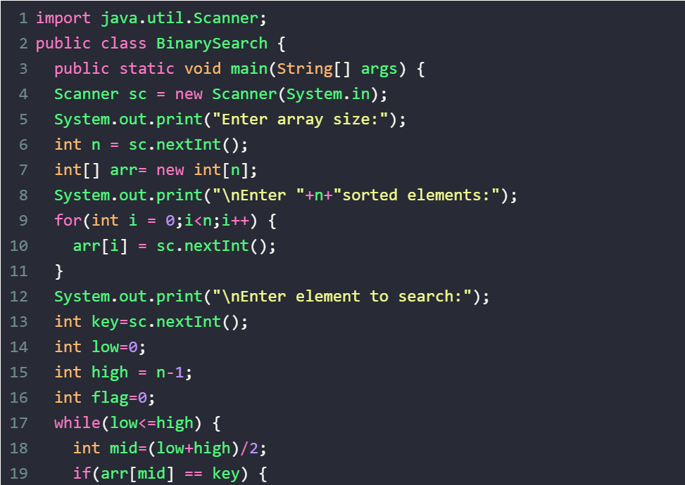
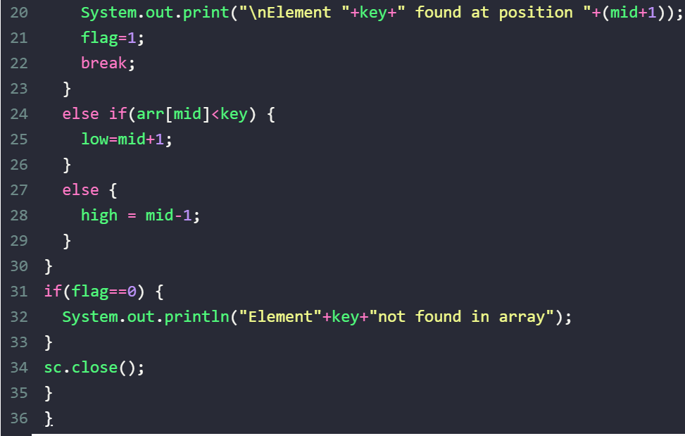
INPUT:
5
2 4 6 8 10
8
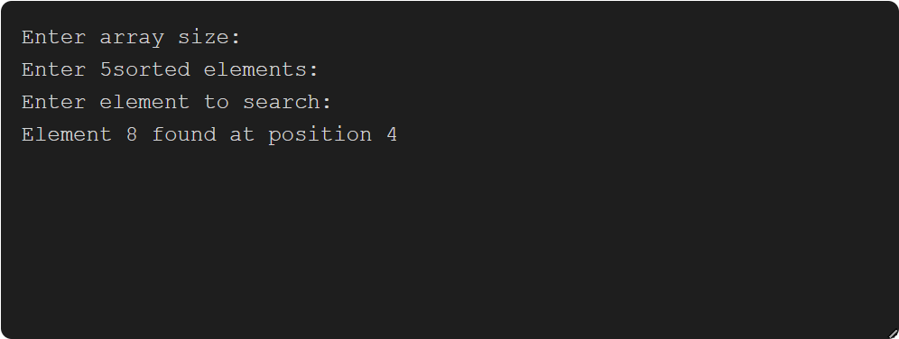

PROGRAM 8: GCD Write a Java program to find the GCD (Greatest Common Divisor) of two numbers using loops and conditional statements.
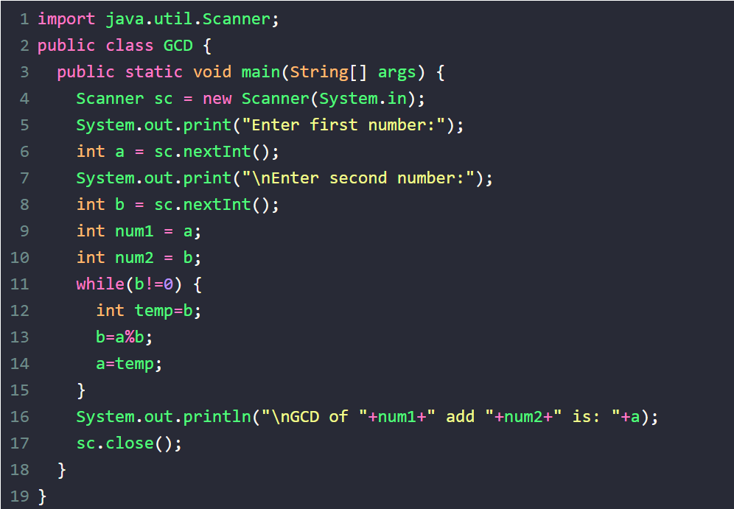
INPUT:
12
8
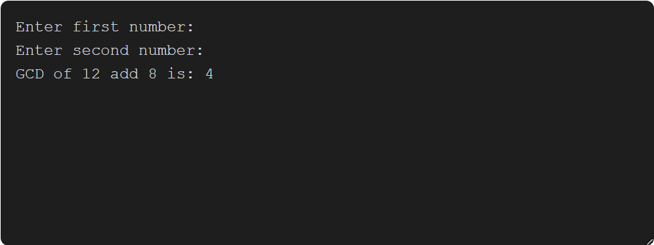

PROGRAM 9: PRIME Write a Java program to check whether a given number is a prime number or not using loops and conditional statements.
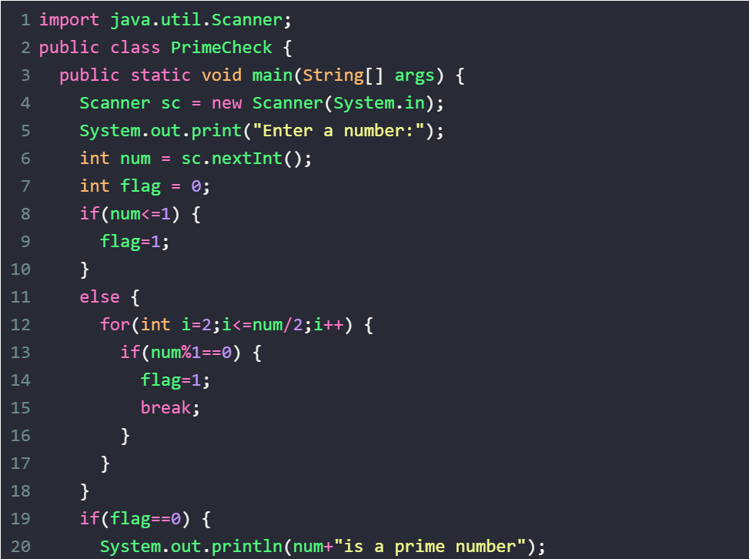
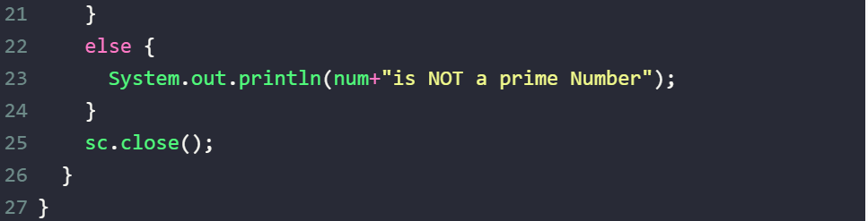
INPUT: 16
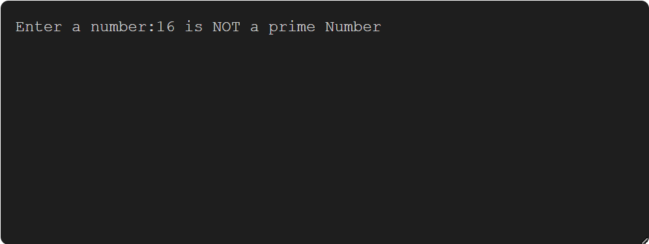
PROGRAM 10: SORT Write a Java program to implement selection sort on an array of integers using loops and conditional statements.
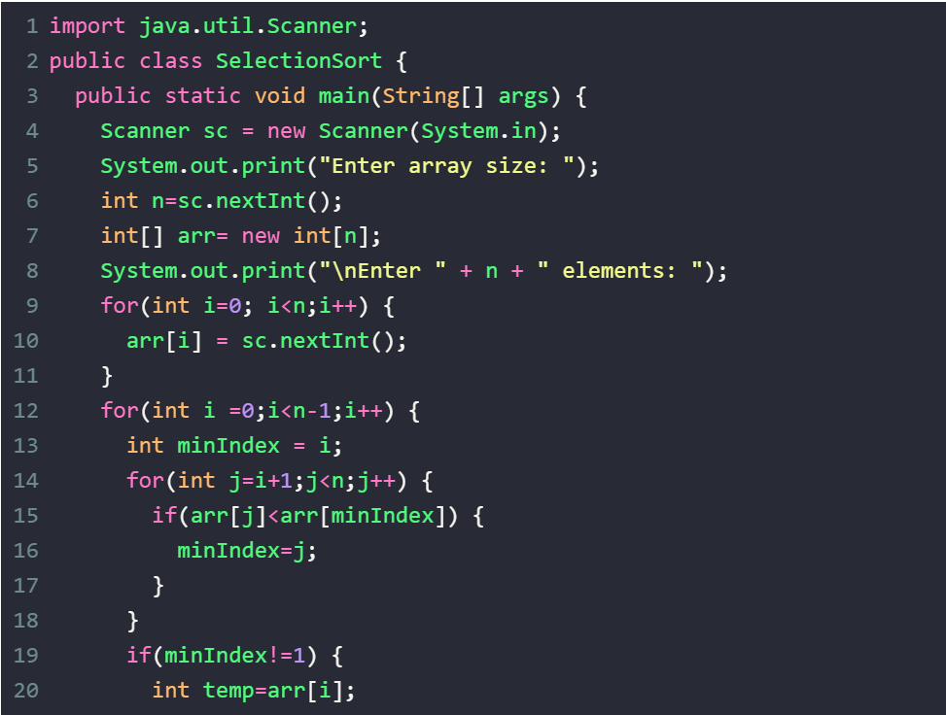
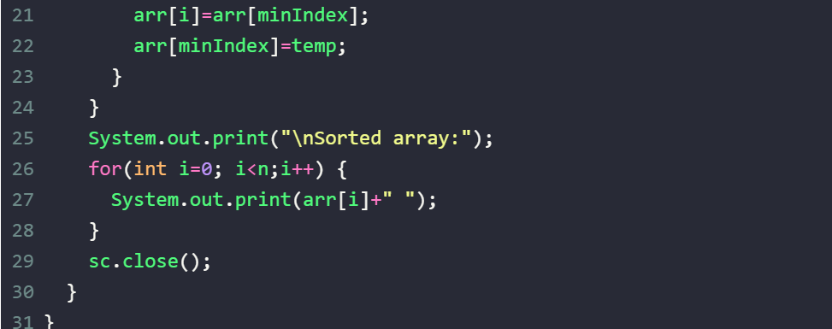

INPUT:
5
10 20 30 40 50
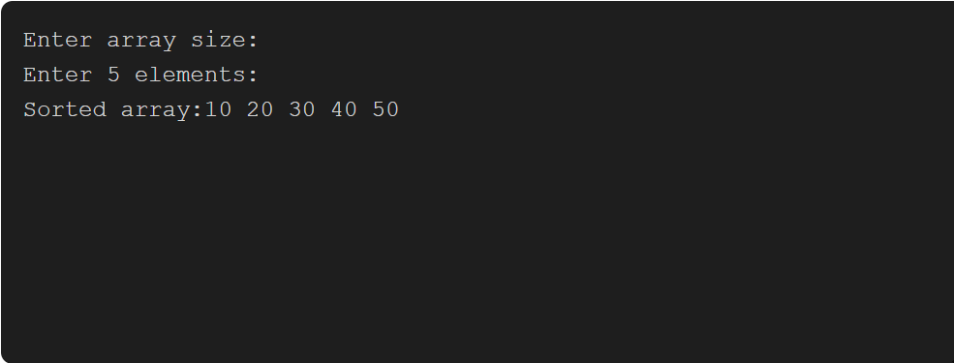

PROGRAM 11: TABLE Write a Java program to print the multiplication table of a given number using loops.
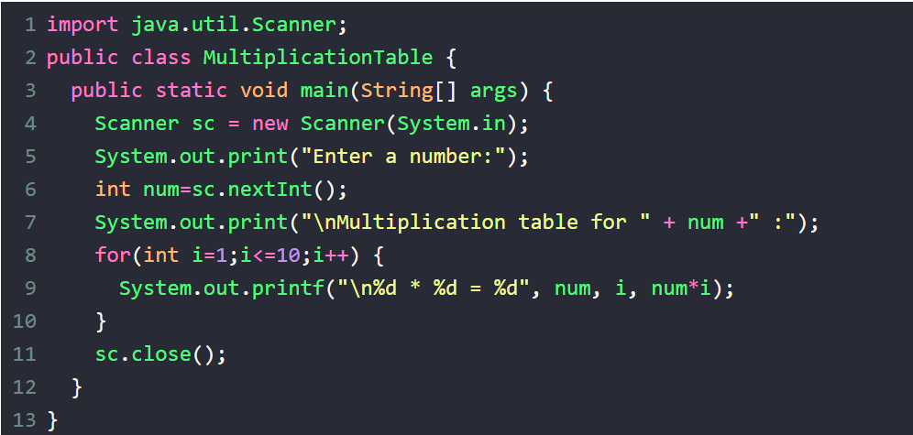
INPUT: 3
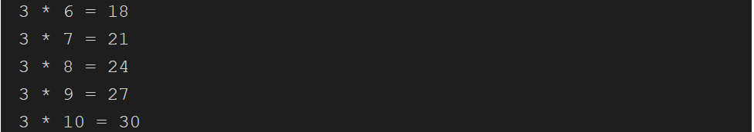
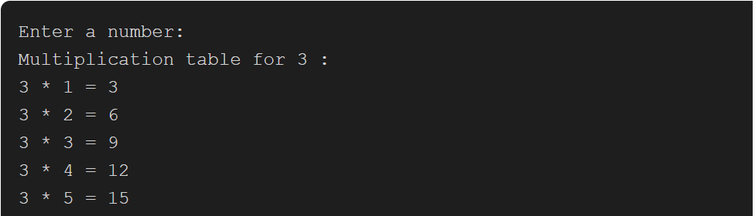

PROGRAM 12: FACTORIAL Write a java program to find the factorial of the given number using recursion
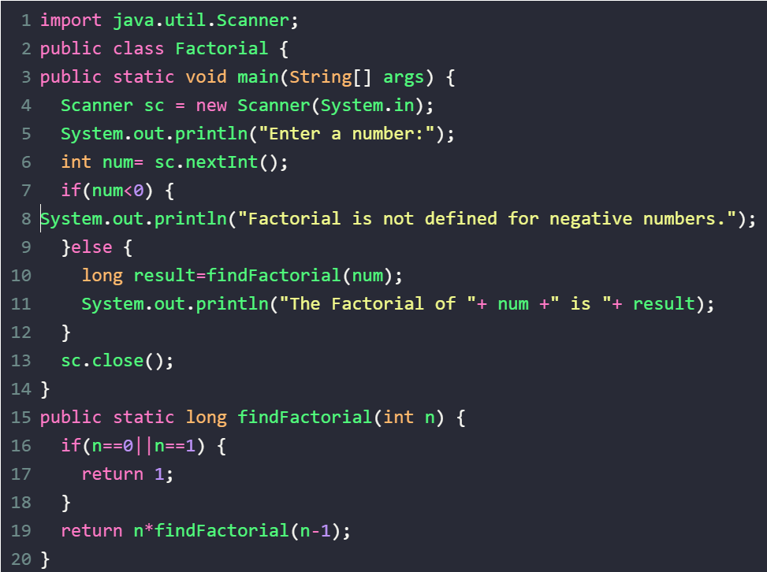
INPUT: 3
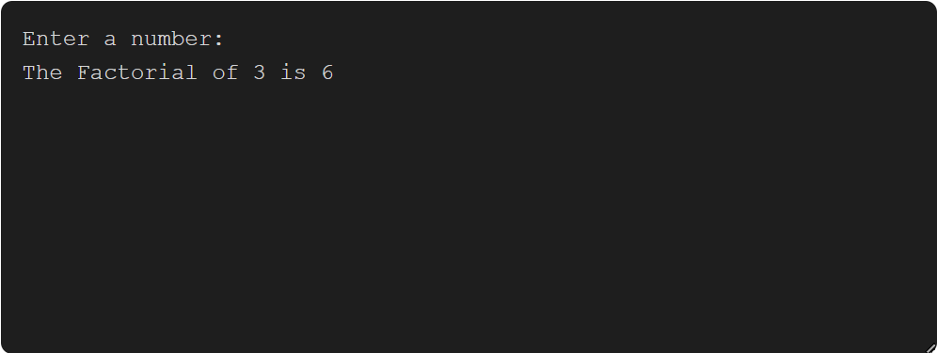

PROGRAM 13: LT-PATTERN Write a Java program to print the following pattern using loops:
*****
****
***
**
*
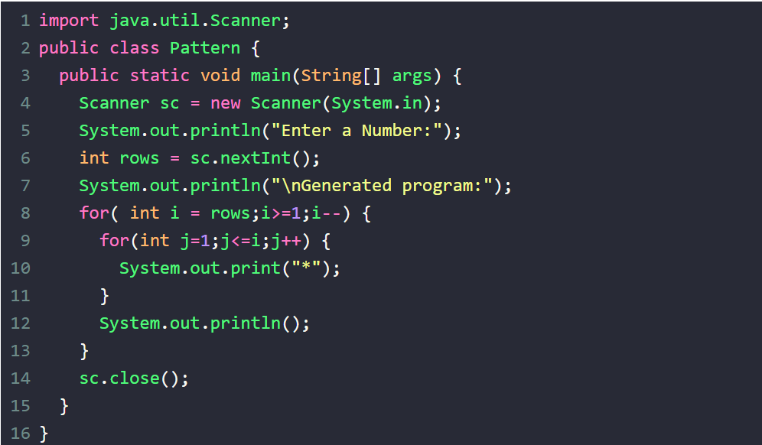
INPUT: 5
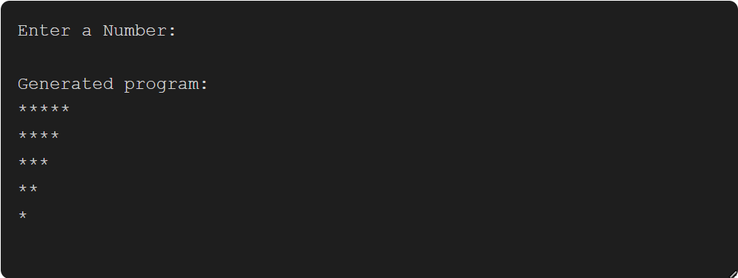
PROGRAM 14: LCM Write a Java program to find the LCM (Least Common Multiple) of two numbers using loops and conditional statements.
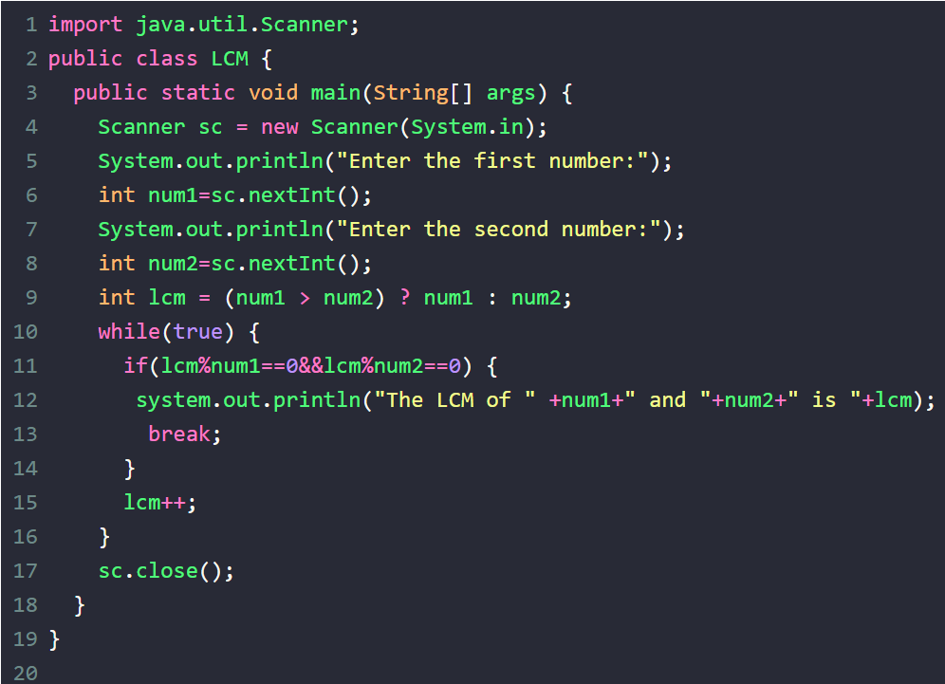
INPUT:
10 11
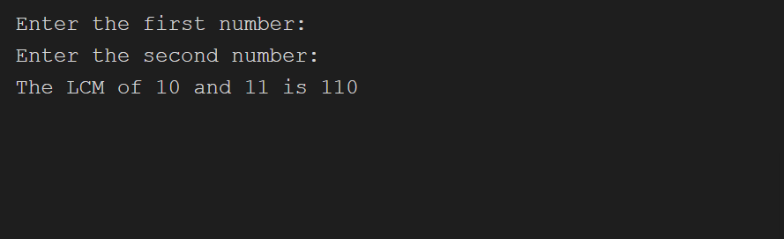

PROGRAM 15: D TO B Write a Java program to convert a decimal number to binary using loops and conditional statements.
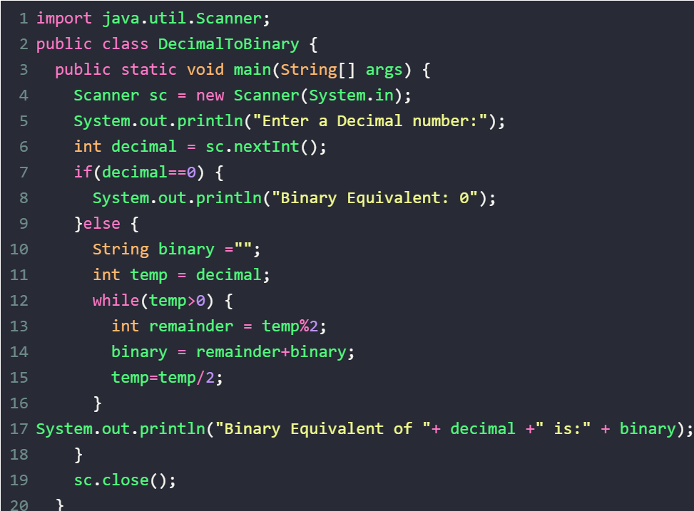
INPUT: 10
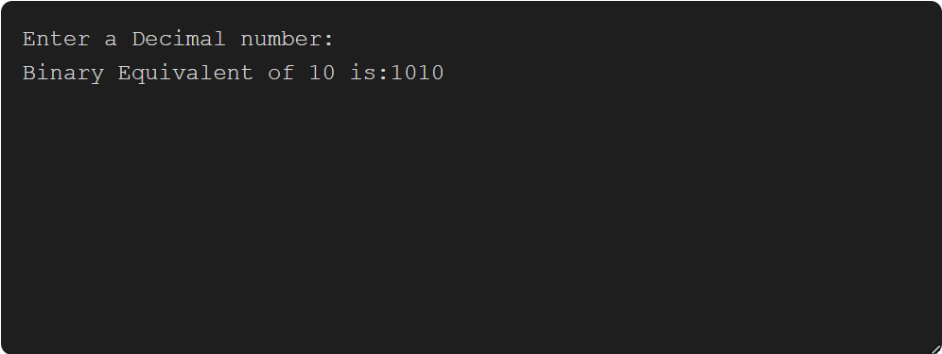

PROGRAM 16: B TO D Write a Java program to convert a binary number to decimal using loops and conditional statements.
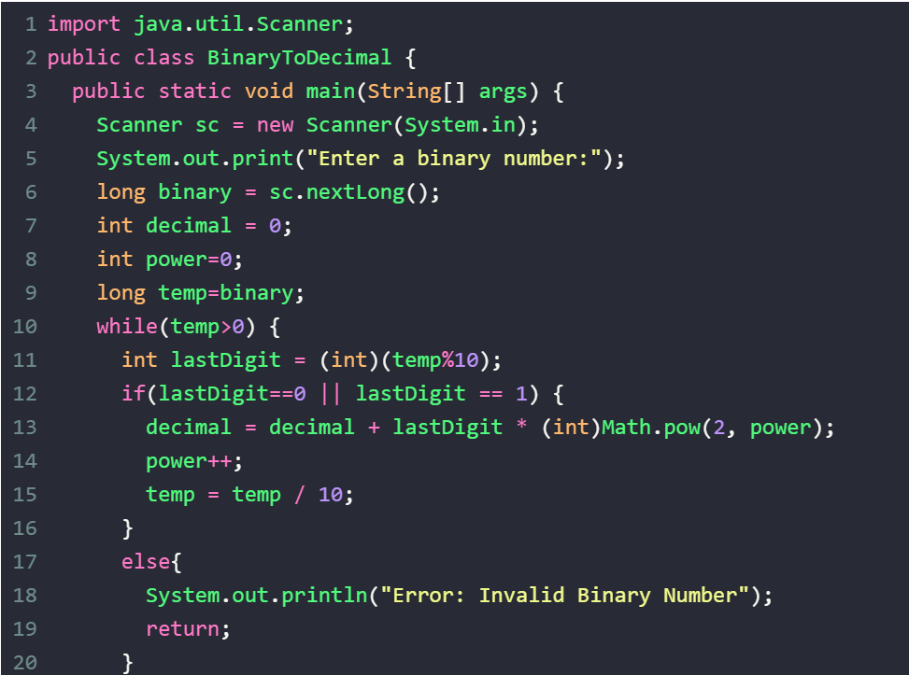
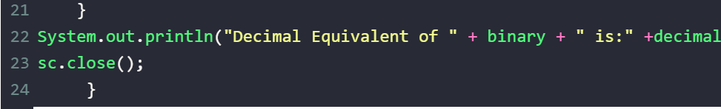
INPUT: 1011
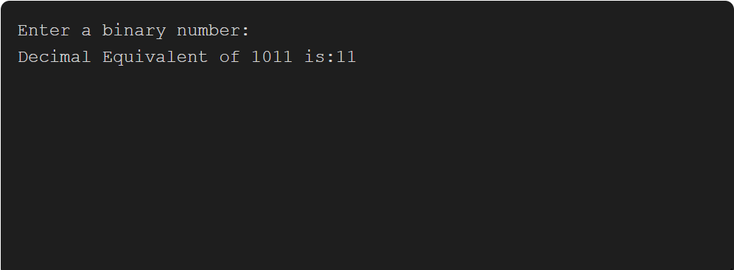
PROGRAM 17: SUM Write a java program to calculate the sum of the digits of a given number using loops and conditional statement.
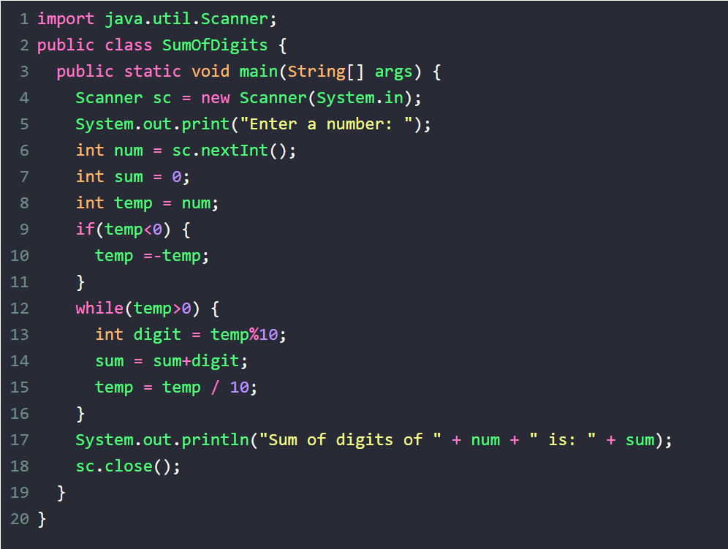
Input: 1234
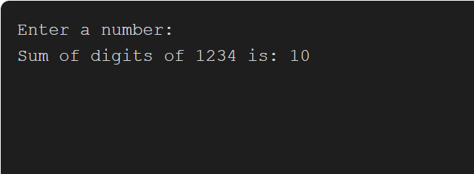

PROGRAM 18: PRODUCT Write a java program to calculate sum of the given digits using loops and conditional statements.
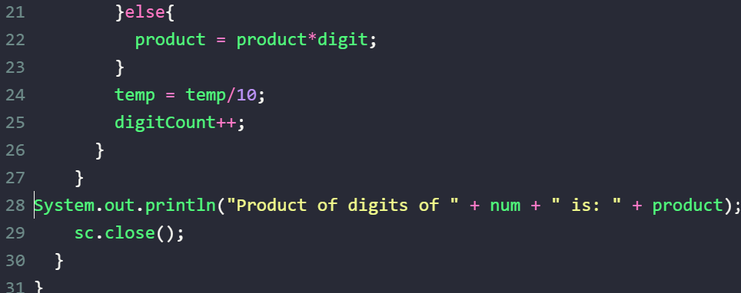
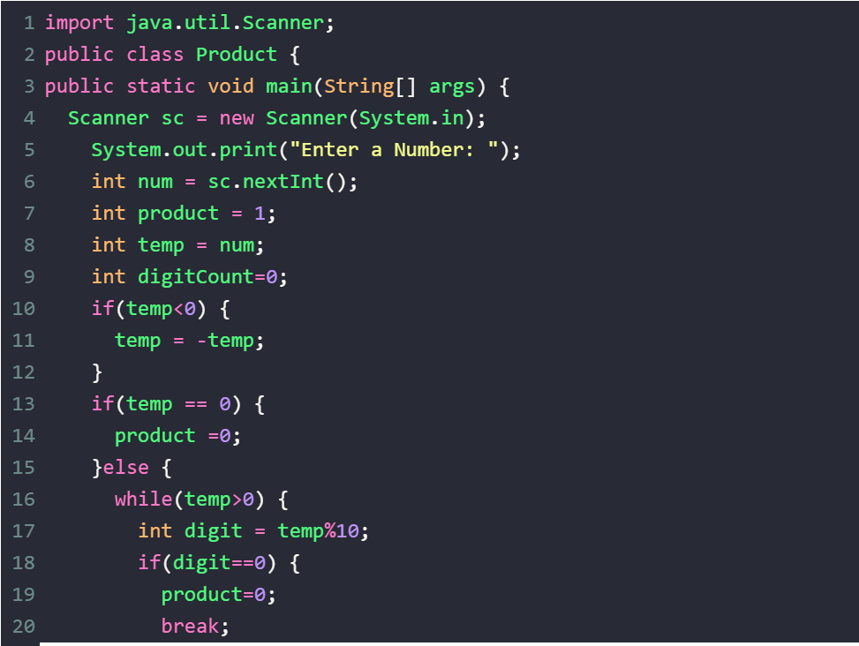
INPUT: 1234
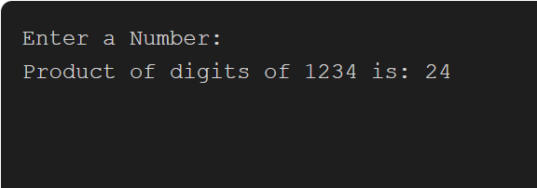

PROGRAM 19: POWER Write a java program to find the a number using loops and conditional statements. 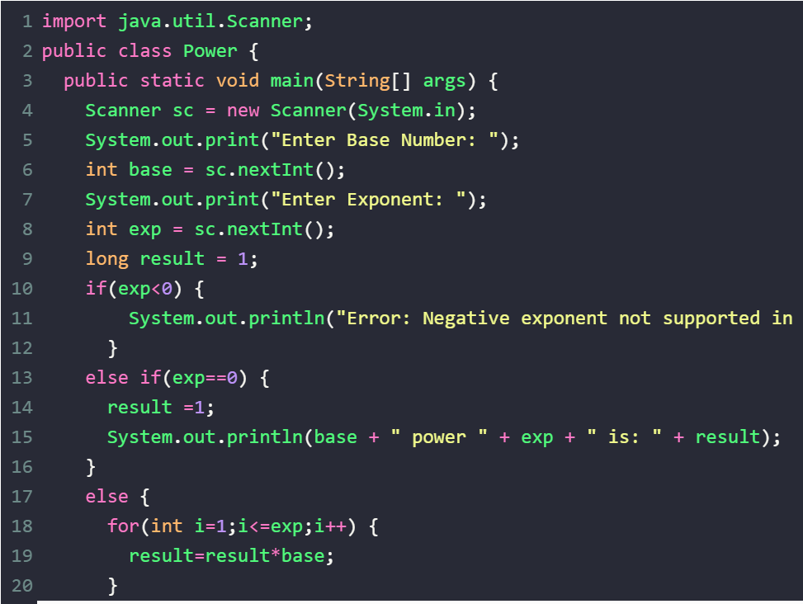
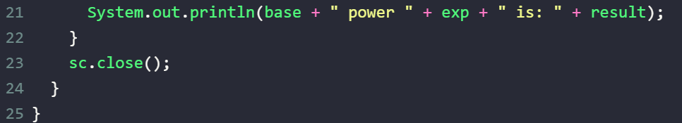
INPUT:
2
4
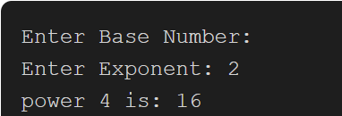

PROGRAM 20: Area Circle Write a java program to calculate the area of the circle by radius input by user.
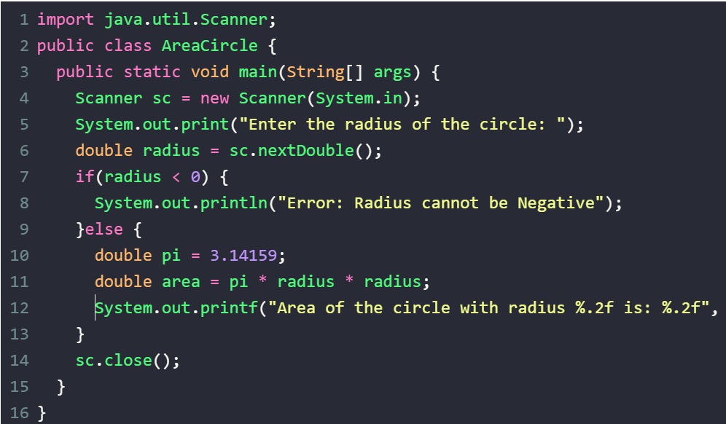INPUT: 5
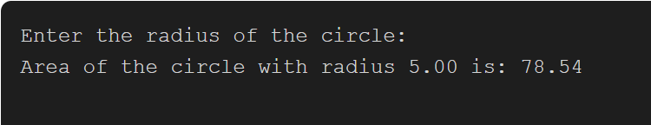

PROGRAM 21: SPHERE Write a java program to calculate the volume of the sphere using the radius input by user.
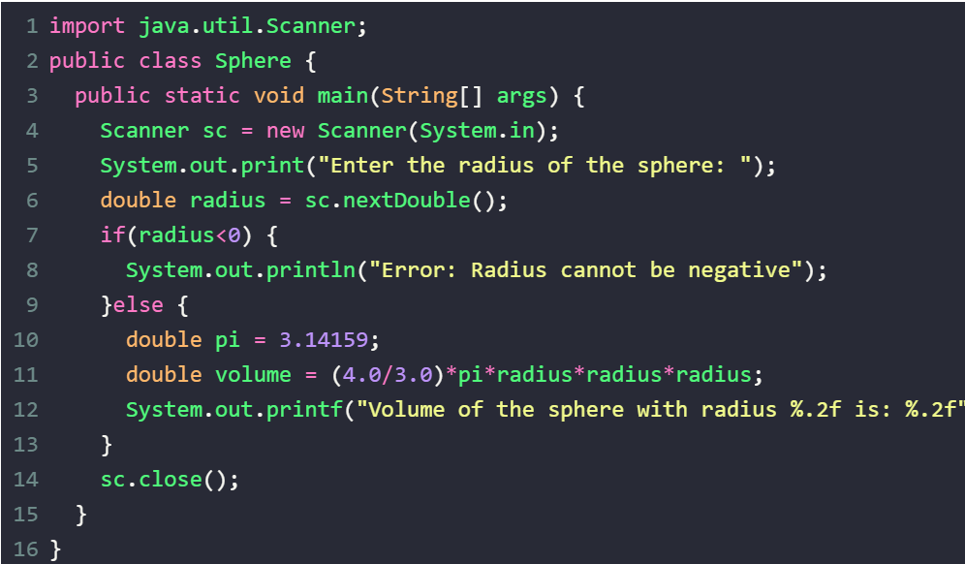input:
3
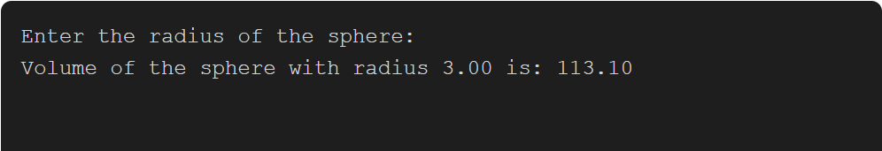

PROGRAM 22: palindrome Write a java program to check whether the given string is palindrome or not using loops and conditional statements.
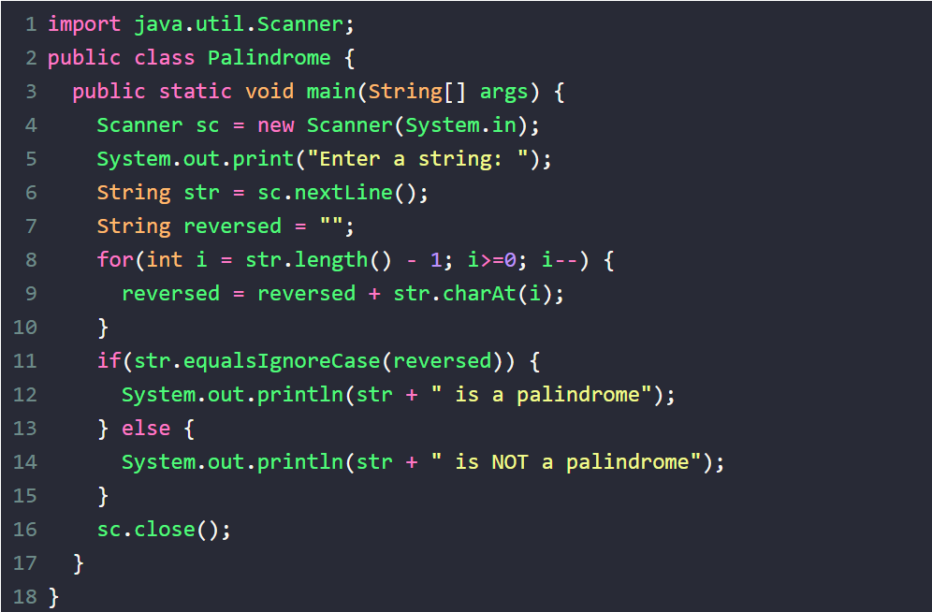INPUT:
Madam
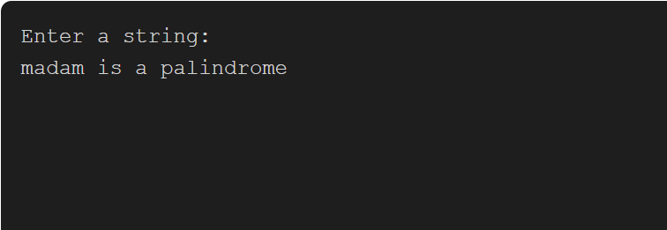

PROGRAM 23: ARMSTRONG Write a java program to check whether the given number is Armstrong or not using loops and conditional stateme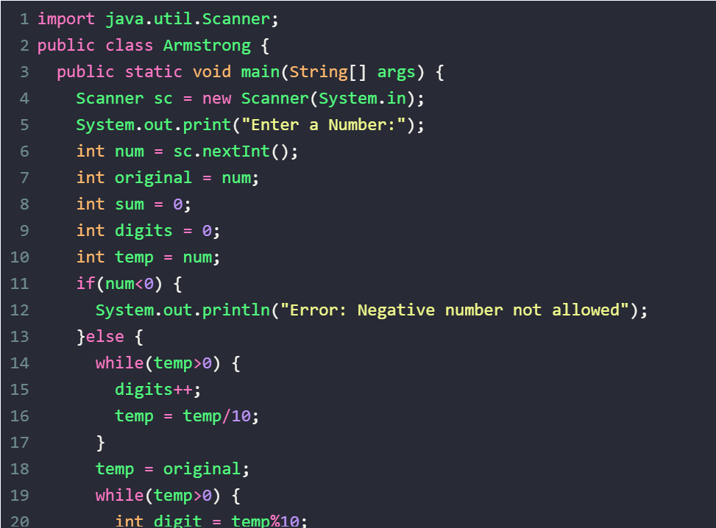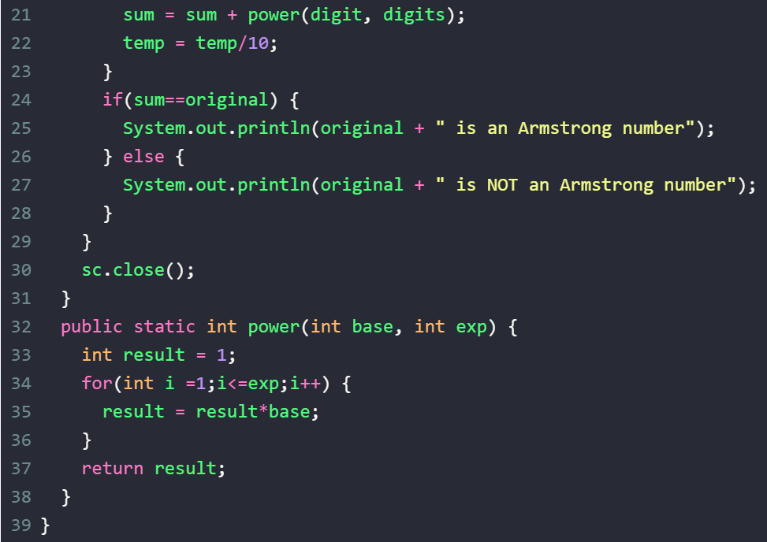

Input: 153
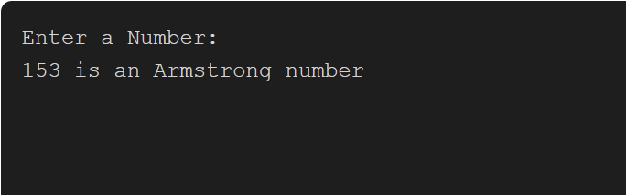

PROGRAM 24: RT-NUM-PATTERN write a java program to display the following pattern:
1
22
333
4444
55555
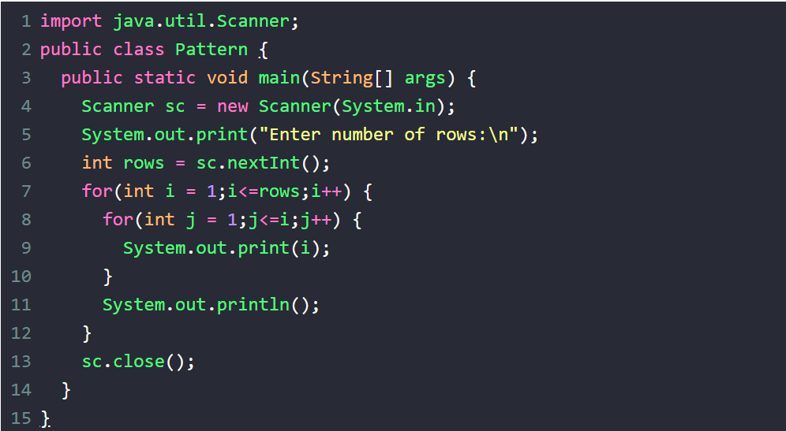input: 5
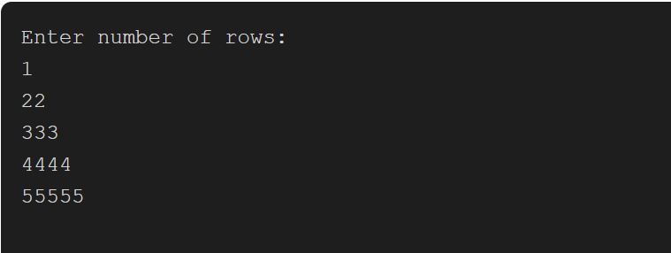
PROGRAM 25: PERFECT Write a java program to check whether the given number is perfect or not using loops and conditional statements.
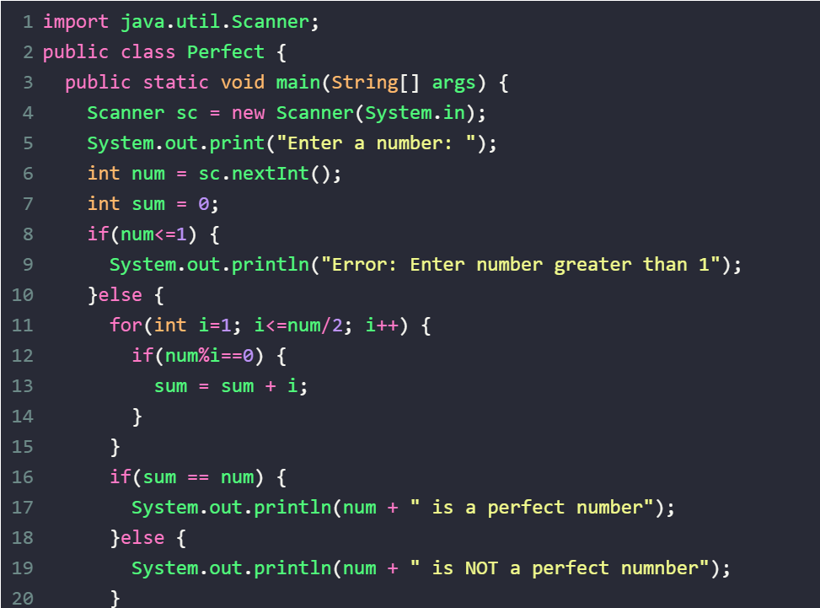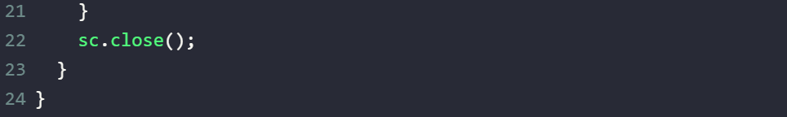input:
6
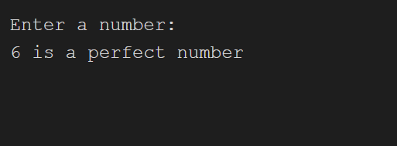

PROGRAM 26: maxarray write a java program to find the largest element is an array of integer using loops and conditional statements.
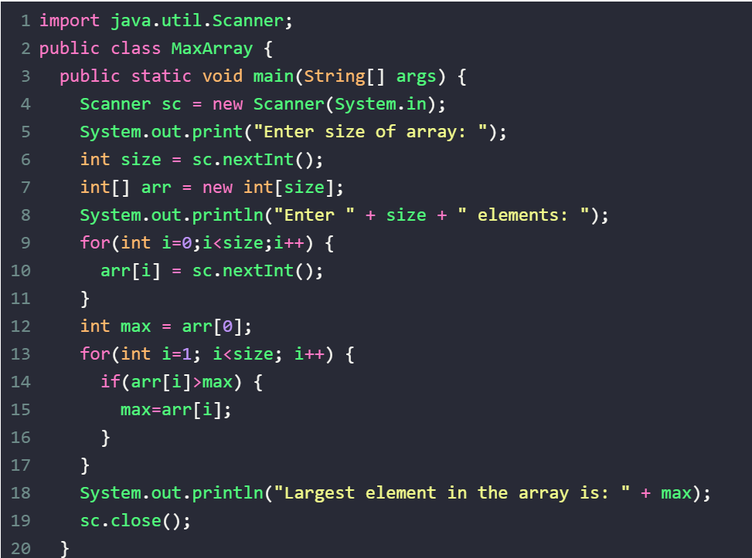input:
5
5
12
3
18
7
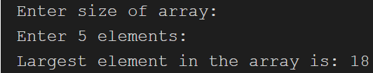
PROBLEM 27: 2ND MAX Write a Java program to find the second largest element in an array of integers using loops and conditional statements.
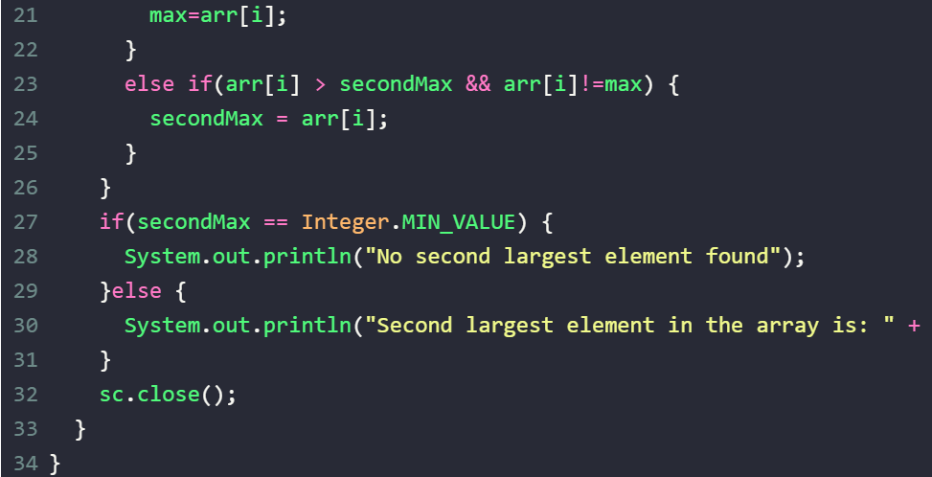
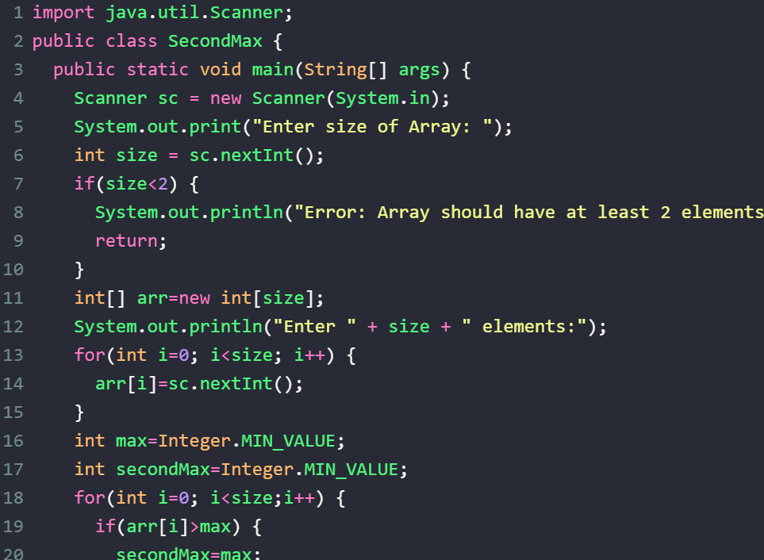

INPUT:
5
12
35
10
35
25
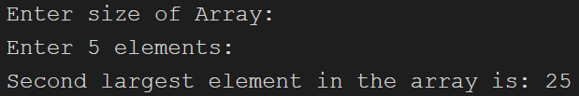

PROGRAM 28: MIN Write a Java program to find the smallest element in an array of integers using loops and conditional statements.
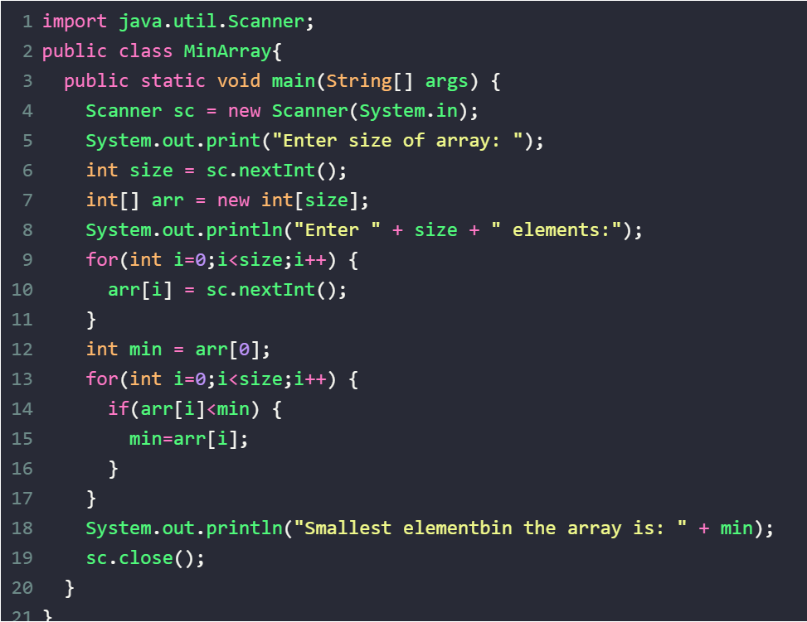
INPUT:
5
15
8
3
20
6
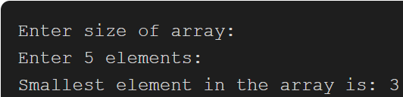
PROGRAM 29: 2ND MIN Write a Java program to find the smallest element in an array of integers using loops and conditional statements.
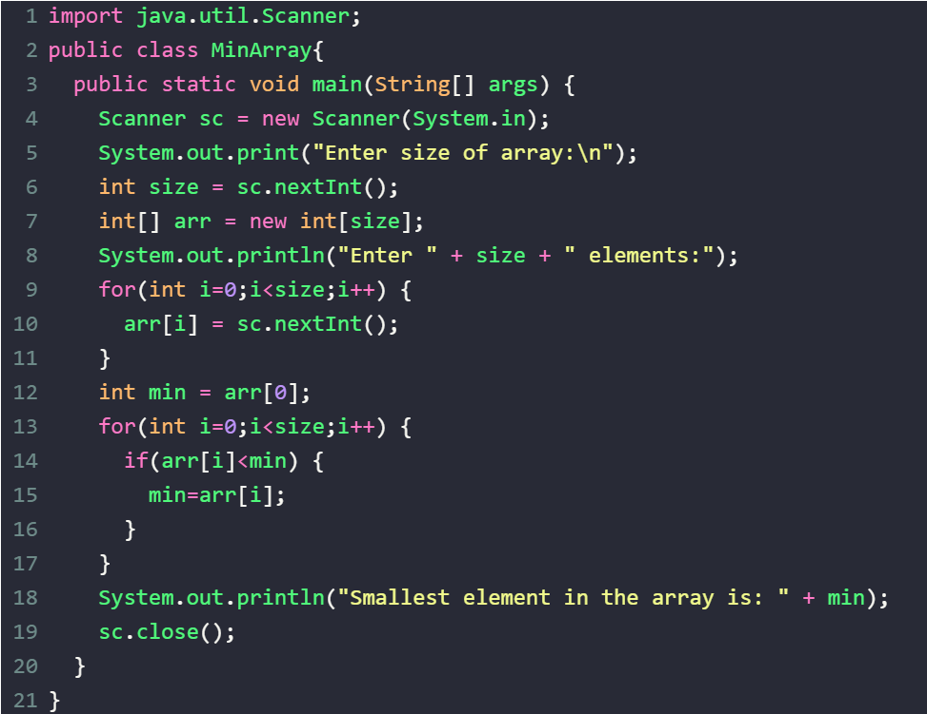

Input:
5
15
8
3
20
6
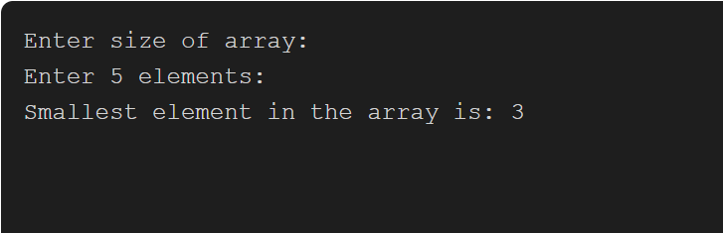

PROGRAM 30:SORT-B Write a Java program to implement bubble sort on an array of integers using loops and conditional statements.
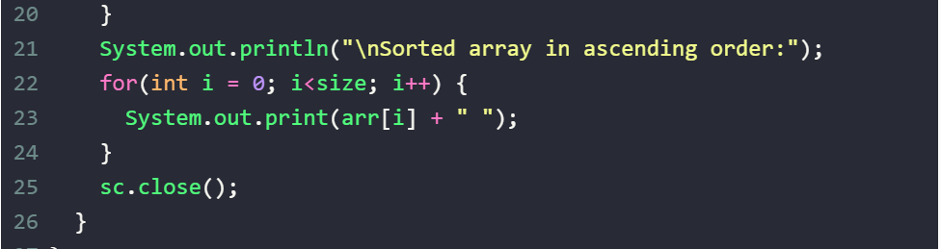
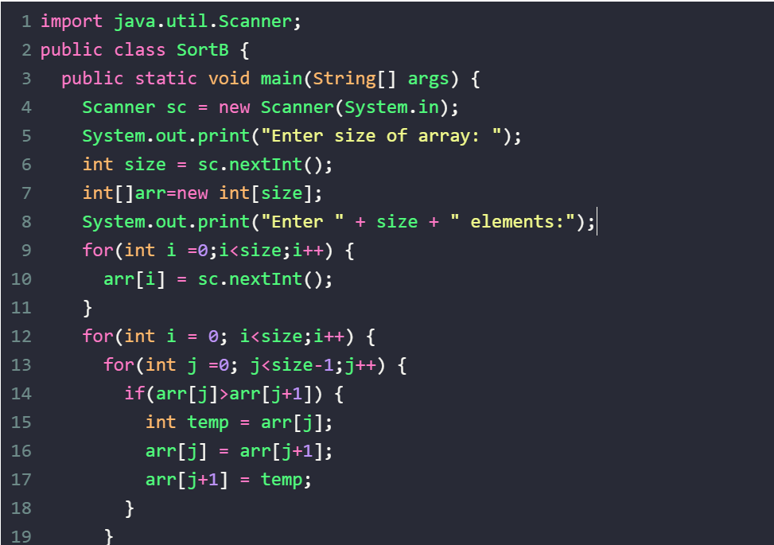
INPUT:
5
5
1
4
2
8
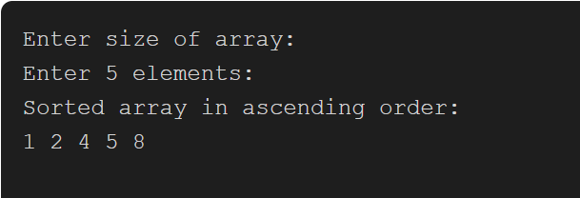

PROGRAM 31: SORT-I Write a Java program to implement insertion sort on an array of integers using loops and conditional statements.
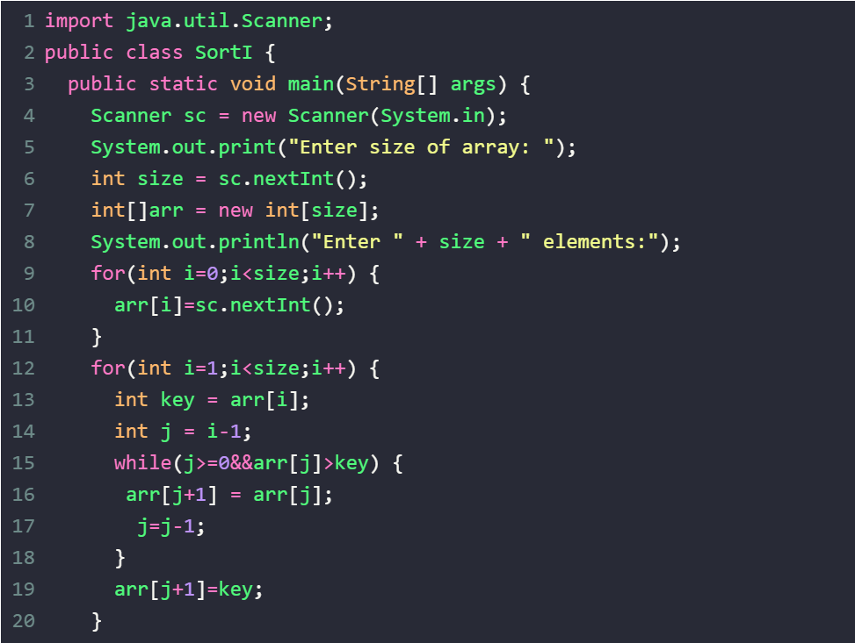
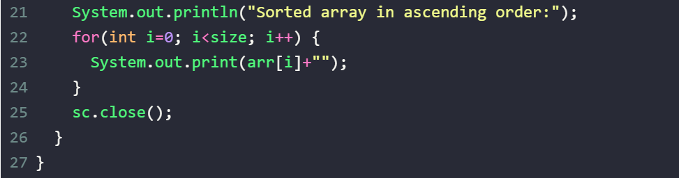
INPUT:
5
5
4
3
1
2
